Sultan Qaboos University

College of Science – Department of Computer Science

COMP3700: Introduction to Web Computing – Spring 2023

Project - Part Three - JavaScript and Dynamic HTML

SQU Market

Team Members: ID:

1. Mohammed Mattar Alshamsi 122711
2. Ahmed Said Alghafri 129520
3. Ammar Abdullah Al Balushi 137497

# JavaScript website pages:

1. Index page:

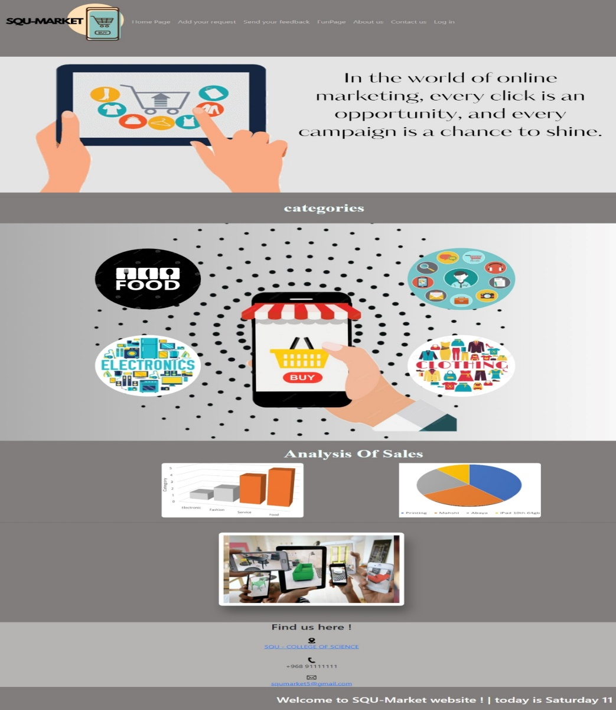

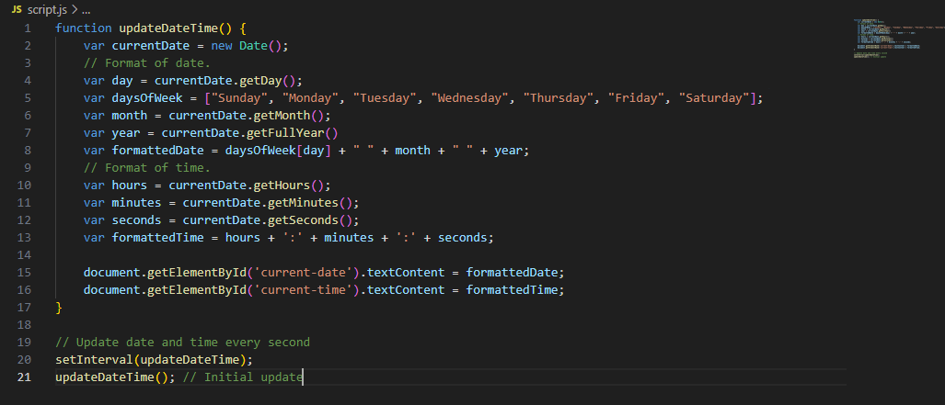

1. Send your feedback page:

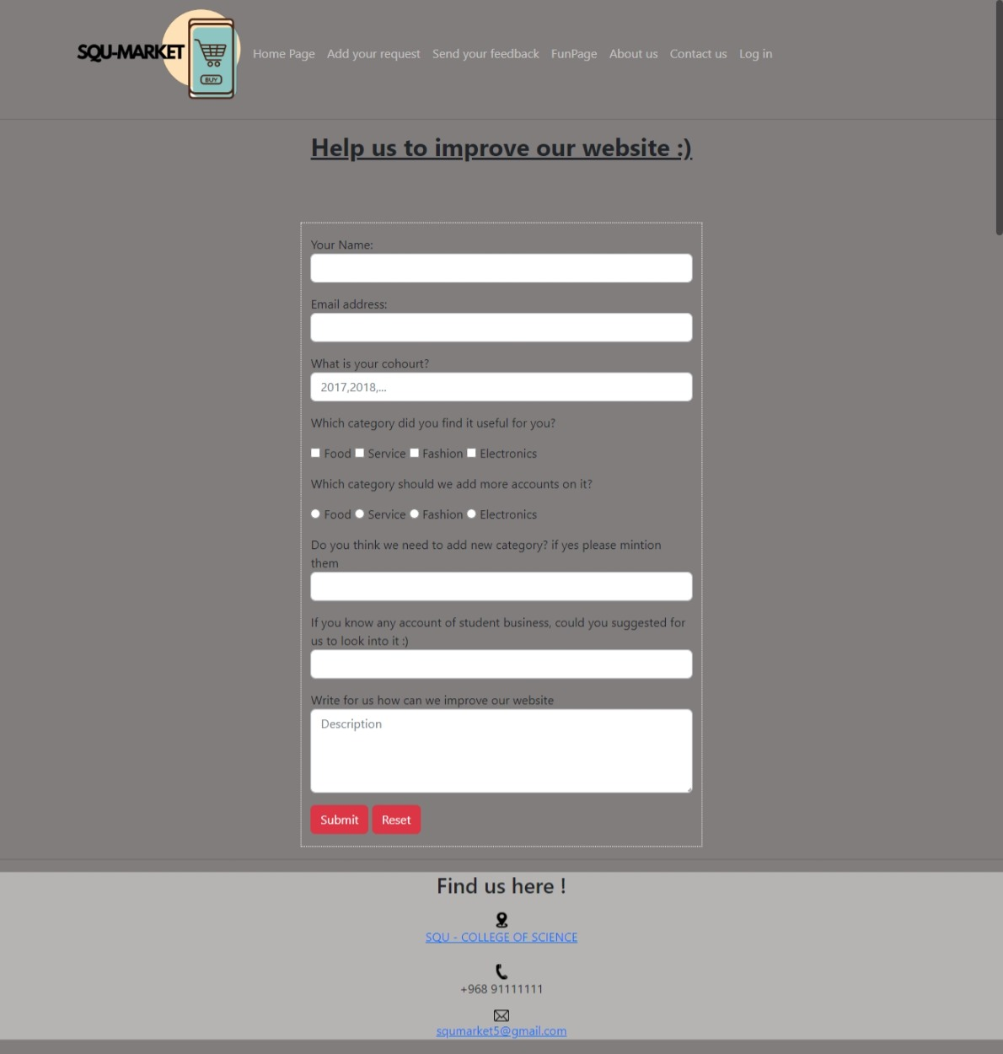

1. Fun page:

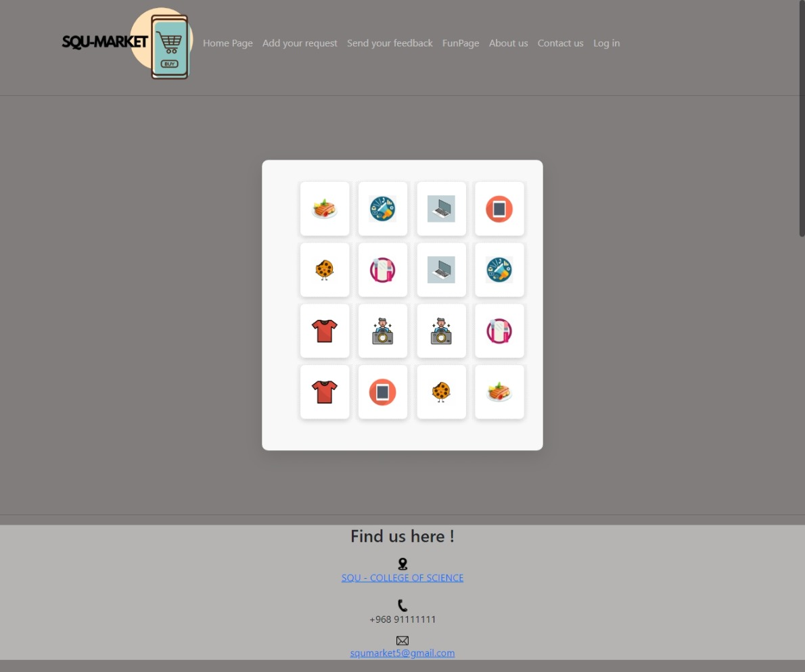

# Order page:

# Table of requirement 1:

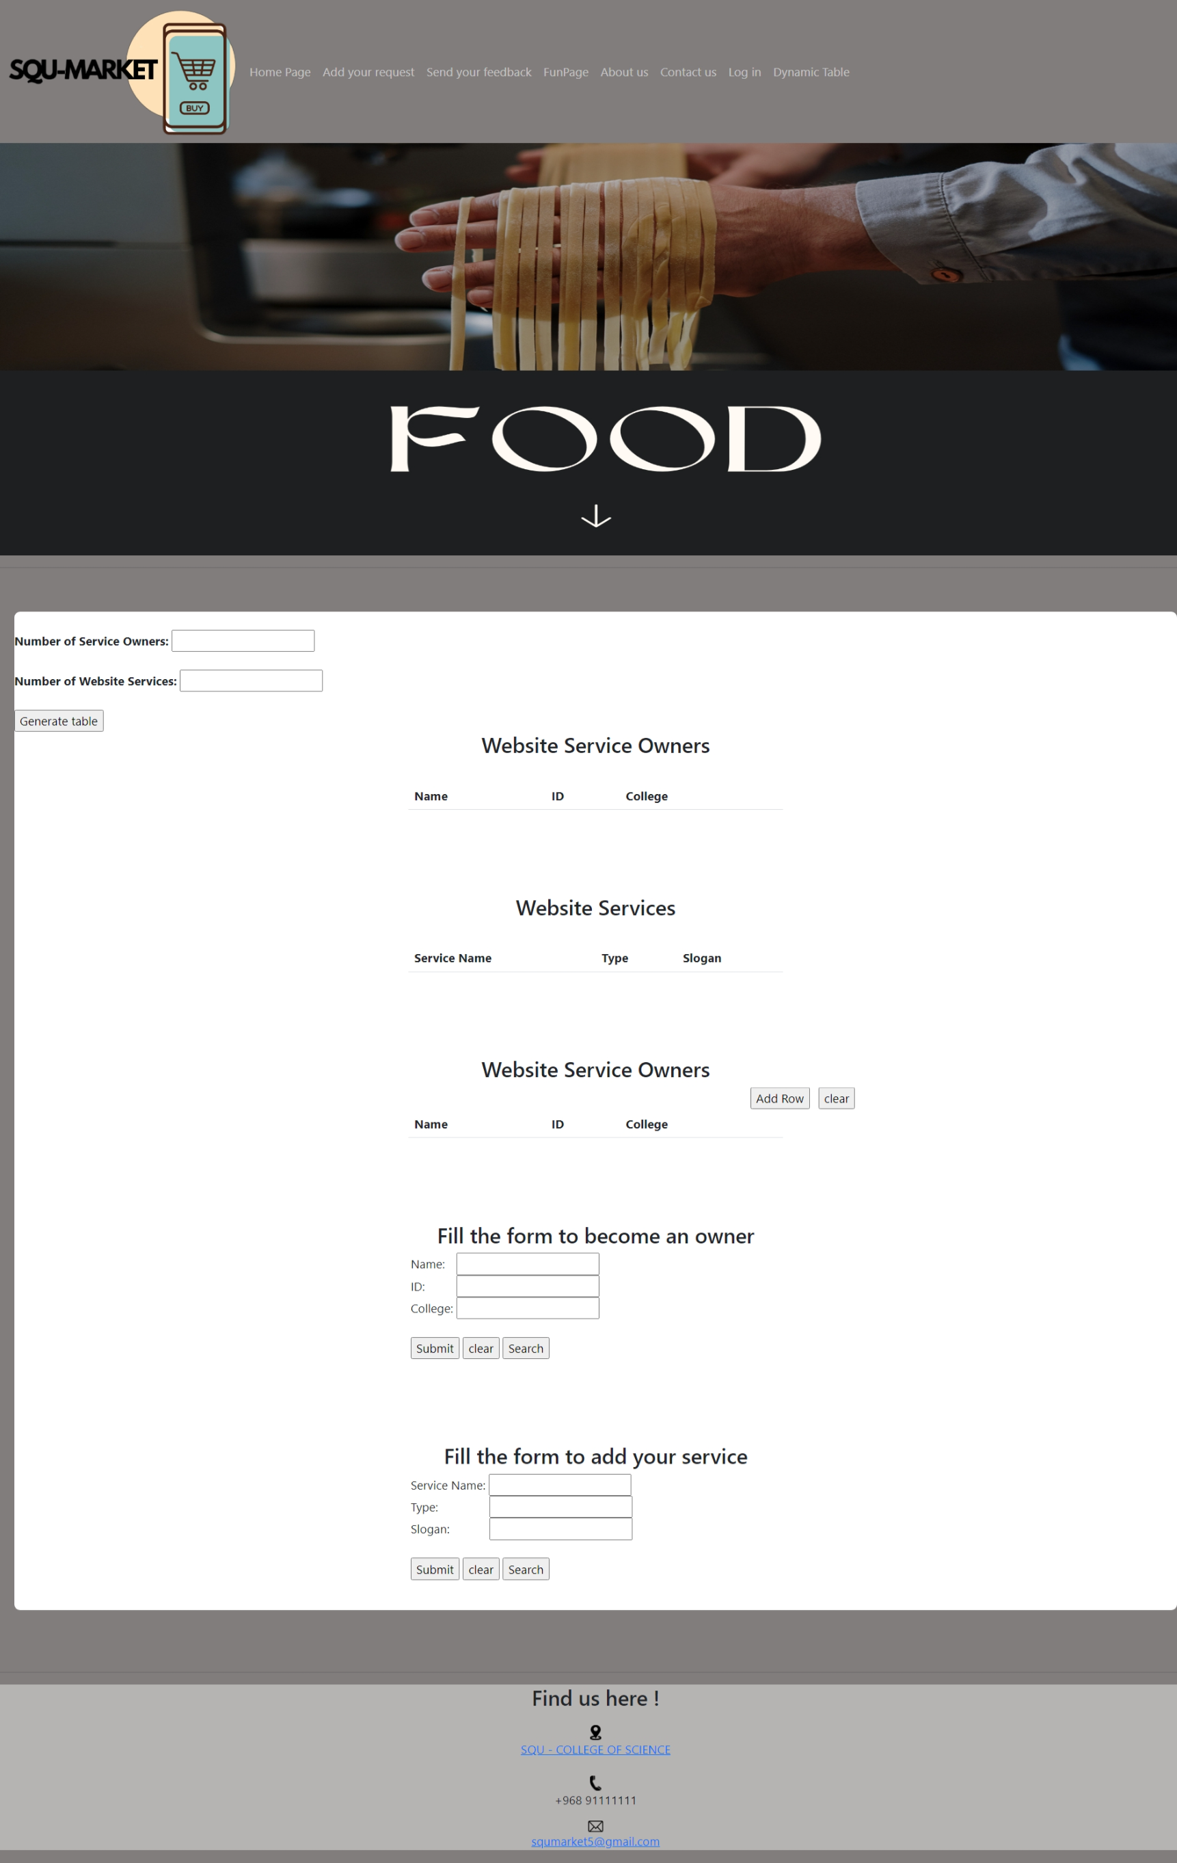

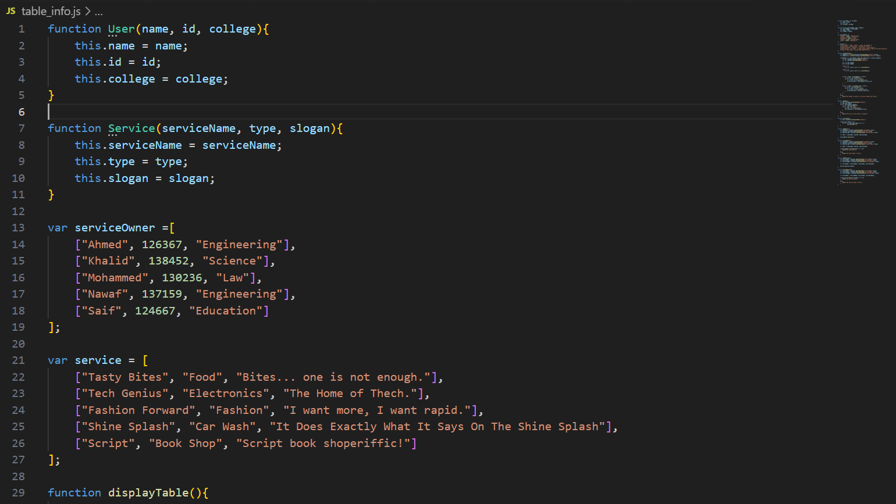

# Contribution Table:

|  |  |
| --- | --- |
| Ammar Abdullah Al Balushi 137497 | * First requirement (Table). * calculation Page. |
| Ahmed Said Alghafri 129520 | * Update **index.html** page. * The report. |
| Mohammed Mattar Alshamsi 122711 | * Questionnaire page. * Fun page. |